Updated on 01/04/2022
Mandatory Disclosure
01 | AICTE File No | 1-9322966760
 | Date & Period of last approval | 30thApril, 2020 for A.Y. 2020-21
02 | Name of the Institution | Institute of Science, Poona’s Institute of Business Management & Research
 | Location Map | 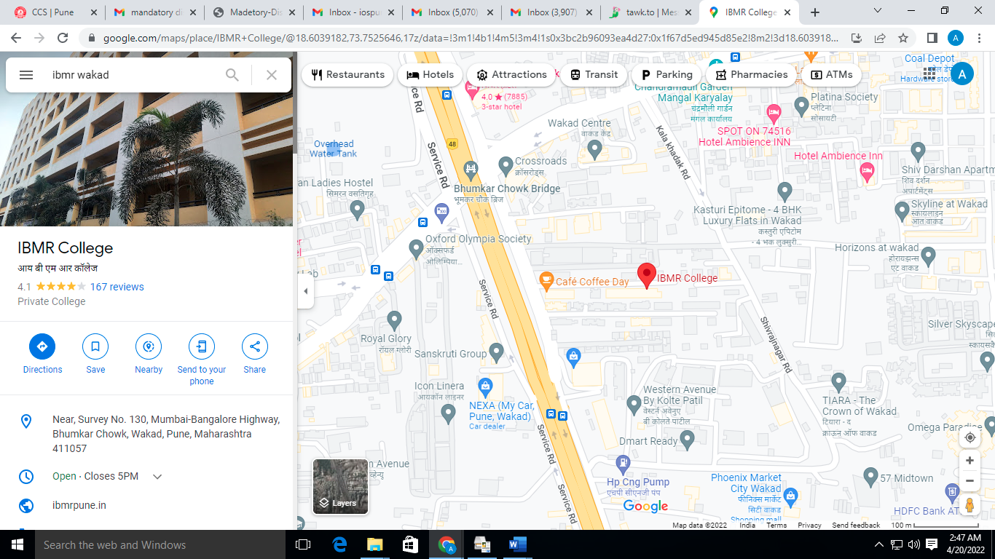
 | Address of the Institution | Sr. No. 130, Mumbai-Bengaluru Highway, Near Bhumkar Chowk, Behind Zen Business Center, Wakad, PUNE
 | City & Pin Code | Pune- 411 057
 | State/UT | Maharashtra
 | Longitude & Latitude | 73.739604 & 18.5910757 respectively
 | Phone Number with STD code | 020-67174200
 | Fax Number with STD code | 020-67174200
 | Office hours at the institution | 10.00 a.m.to 6.00 p.m.
 | Academic hours at the institution | Shift-1: 9.00 a.m. to 5.30 p.m.
 | Email | ibmrwakadpune@gmail.com
 | Website | www.ibmrpune.in
 | Nearest Railway Station | Chinchwad 6.0 KM
 | Nearest Airport | Lohgaon, Pune: 30 KM
03 | Type of institution | Unaided Private Professional Institute
 | Category (1) of the institution | Non-Minority
 | Category (2) of the institution | Co-Ed
04 | Name of the parent organization running the institution | Institute of Science, Poona
 | Type of Organization | Trust, Society
 | Address of the organization | Apte Prashala, Deccan Gymkhana, Pune-411004
 | Registered with | Charity Commissioner, Pune, under Bombay Public Trust Act, 1950
 | Date of Registration | 8th April, 1969
 | Website of the organization | www.ibmrpune.in
05 | Name of the affiliating University | Savitribai Phule Pune University
 | Address | Ganesh Khind Road, Pune-411 007
 | Website | www.unipune.ac.in
 | Latest affiliation period | Permanent Affiliation from 2016-17
06 | Board of Trustees - Names | Designation
 | Shri. S. K. Karandikar | Chairman
 | Mrs. Mandakini Nilkanth Joshi | Member
 | Dr. Mrs. Madhura Prasad Joshi | Member
 | Shri. Prasad Nilkanth Joshi | Member-Secretary
 | Dr. Mrs. Madhura Prasad Joshi | Member
 | Shri. Anant Zanjale | Member
 | Adv. Siddhi Joshi | Member
 | Mr. Rajiv Potdar | Member
07 | Name of the Director | Prof. Dr. Roopali Kudare
 | Exact Designation | Director
 | Phone Number with STD code | 020-67174200
 | Fax Number with STD code | 020-67174200
 | Email | director@ibmrpune.in
 | Highest Degree | Ph.D
 | Field of Specialization | Finance & Marketing
08 | Governing Board Members
(a) | Names of the Members of the Governing Body: | Designation
1 | Shri. Prasad N. Joshi | Chairman  Trustee, Institute of Science, Poona
2 | Dr. Mrs. Madhura Prasad Joshi | Member  Trustee, Institute of Science, Poona
3 | C.A. Shri. Vilas Potdar | Member  Industry
4 | Nominee-W.R.O. AICTE-Mumbai | Ex-officio-Member
5 | Nominee-D.T.E. Mumbai | Ex-officio-Member
6 | Nominee-S.P. Pune University | Member
7 | Nominee-State Government | Member
8 | Prof. Dr. Omkar Gadre | Member  Faculty
9 | Prof. Dada Patil | Member  Faculty
10 | Dr. Roopali Kudare | Member  Secretary
 | Frequency of Meetings and date of last meeting | Twice a year
 | College Development Committee | Four times a year
 | Frequency of Meetings and date of last meeting | Twice a year for Local Managing Committee; Date: 17/12/2020

COLLEGE DEVELOPMENT COMMITTEE
Ref: Maharashtra Public Universities Act, 2016 Sec-97 (1)

09
Sr. No. | Name of the Member | Designation
1 | Shri. Prasad N. Joshi | Chairman  Nominee of Institute of Science, Poona
2 | Dr. Mrs. Madhura Joshi | Nominee-Secretary, Institute of Science, Poona
3 | Dr. Omkar V. Gadre | Member (HOD-Computer Department)
4 | Prof. ChhayaVanjare | Member – Teaching Representative
5 | Prof. Rohini Nikam | Member – Teaching Representative
6 | Prof. Dada S. Patil | Member – Teaching Representative
7 | Prof. Renuka Vanarse | Member – Teaching Representative
8 | Shri. Sagar Bobade | Member – Non-Teaching Representative
9 | Dr. N. B. Pasalkar | Member - Education
10 | Shri. Vilas Potdar | Member - Industry
11 | Dr. Manohar Rajarshi | Member - Research
12 | Mr. Vivek Pandit | Member Alumnus
13 | Dr.Roopali Kudare | Member- (Coordinator, IQAC)
14 | Ms. Sakshi Ramtekkar | Member-Students Council-President
15 | Ms. Sayali Patil | Member-Student Representative
16 | Dr. Roopali Kudare | Member-Secretary

10 | Organizational Chart
Board of Trustees

Coordinator

Director

Academic Library Computer Lab Administration

Professor Librarian faculty In charge Registrar

Associate Professor Jr. Library Asst. Technical Assistant Accountant Head Clerk

Assistant Professor Jr. Library clerk Attendant Peons Sr. Clerk

Attendant Peons Jr. Clerk

Peons Peons

11 | Student feedback mechanism on Institutional Governance/faculty  performance |  | The students are given freedom to give their feedback on faculty and Management of the institution by filing feedback form without mentioning their names, roll numbers or any identity to avoid prejudice.  https://ibmrpune.in/student-feedback-form/
12 | Grievance redressal mechanism for faculty, staff and students:  The Institute has formed various Committees to address the grievances of the students, teachers and non-teaching staff. The Committees are as under;
A | 1) Anti-Ragging Committee and Anti-Ragging Squad (Under Prevention and Prohibition of Ragging in Technical Institution |  | https://ibmrpune.in/anti-ragging-committee/
B | Internal Complaint Committee (Under Ref: Sexual Harassment of Women Employees and Students (Prevention, Prohibition and Redressal), Act 2013 |  | https://ibmrpune.in/internal-complaint-committee/
C | Grievance Redressal Committee  (Under the All-India Council for Technical Education [Establishment of Mechanism for Grievance Redressal) Regulations, 2012 |  | https://ibmrpune.in/students-grievance-redressal-committee/students-grievance-form/  https://ibmrpune.in/students-grievance-redressal-committee/
D | SC-ST Cell: As per the Scheduled Castes and Scheduled Tribes (Prevention of Atrocities) Act, 1989, No. 33 of 1989, dated 11.09.1989 |  | https://ibmrpune.in/sc-st-cell/
E | Students’ Grievance Redressal Cell |  | https://ibmrpune.in/students-grievance-redressal-committee/students-grievance-form/
F | Students’ Development Cell: Maharashtra Public Universities Act, 2016, Sec-56 (2) b |  | https://ibmrpune.in/students-development-cell/
Name of the Department* : No departmental system available.
Course : Master in Business Administration (M.B.A.)
Level UG / PG : Post-Graduate level
1st Year of approval by the Council: Since applicable by of AICTE - 1994
Year wise Sanctioned Intake : CAY-1: 90 CAY-2: 90

Year wise Actual Admissions : CAY-1:53 CAY-2:78
Cut off marks – General quota:
All admissions of MBA course for the academic year 2021-22 are controlled by the Admission Regulating Authority, Mumbai through State Common Entrance Test Cell (MAH-MBA/MMS-C E T-2020)

Results of MBA Batch 2021-22 Passed out in August-2022 – Result Awaited

Students Placed: 18 out of 36 eligible

Average Pay package, Rs. /Year: CAY: Rs.6,11,600

Students opted for Higher Studies: Record not available
Accreditation Status of the course: Accredited by NAAC with B

Doctoral Courses : No
Foreign Collaborations, if any : No
Professional Society Memberships: Yes -CEGR
Professional activities : Nil
Consultancy activities : Nil
Grants fetched : Yes
Departmental Achievements : Yes

Some of the Distinguished Alumni of I.B.M.R. Wakad

1. Mr. Ishwar Kr. Singh, DGM, AES Pvt. Ltd.
2. Mr. Pradeep Pandey, Manager, Bharti AXA Life Insurance
3. Mr. Sachin Rathi, Manager, HCL
4. Mr. Sachin Bobate, Force Motors, Pune
5. Mr. Shailesh Nilakh, Hero Honda
6. Mrs. Akshada Sathe, Reliance Money, Mumbai
7. Mr. Hemant Shetty, ICICI Bank
8. Ms. Charuta Patwardhan, Seed Infotech
9. Mr. Mashud Hassan, ICICI Bank
10. Mr. Sameer Patil, I Bridge Solutions
11. Mr. SoumitraWaikar, ING Vaisya Insurance
12. Mr. Rahil Shukla, Dy. Manager, HDFC Bank
13. Mr. Atul Inamdar, Praj Industries
14. Mr. Prem Patyal, Canon India
15. Mr. Yogesh Lulla, Hongkong Telecom
16. Ms. RoopaliTeke, Suzlon Energy,
17. Mr. AmeyaSapre, JP Morgan
18. Mr. Darshan Sonar, Bajaj Auto Finance
19. Mr. Yashpal Badime, PepsiCo India Holdings
20. Mr. Yogesh Gawande, Maxwell Industry
21. Sachin R Rathi-ICICI Bank
22. Prashant S Rathi- ICICI Bank
23. Dilip Balan- ICICI Bank
24. S M Hasan- ICICI Bank
25. Jayashree Ingale- ICICI Bank
26. Jyoti Prakash- ICICI Bank
27. Sagar Mukadam- ICICI Bank
28. Uday Shetty- ICICI Bank
29. Dhaval Thakkar- ICICI Bank
30. Kaustubh Bedekar- ICICI Bank
31. Abhishek Upadhyay- ICICI Bank
32. Mansi Bagde- DSK Ltd.
33. Vinod More- Suzlon Energy
34. Guru Rupendranath- Ceasefire Ltd.
35. Abhijeet Nandre- Ceasefire Ltd.
36. SachinBobate-Force Motors
37. Ashish Mantrawadi- Force Motors
38. Sharad Varganti- Force Motors
39. RavirajPoojari- Force Motors
40. Hillol Sen-Indiabulls
41. Amit Sharma- Indiabulls
42. SaureshChakraborti- Indiabulls
43. Mausam Baruwa- Indiabulls
44. Sagar Sawant- Indiabulls
45. Ganesh Zarkar- Indiabulls
46. Jagdish Palve- Indiabulls
47. Rahul Kulkarni- Indiabulls
48. C.Karandikar- Indiabulls
49. Sudhir Yadav- Indiabulls
50. Amit Mishra- Indiabulls
51. Prerita Agrawal- SHCIL
52. Kavita Gangwar- Birla Shloka
53. Shailesh Nilakh-SaiService Ltd.
54. Mangesh Ingale- SaiService Ltd.
55. Mangesh Aakhade- SaiService Ltd.
56. Rajesh Kumar- Ascent Systems
57. ShantuBorde- Kotak Securities
58. Prashant Patil- Sabero Organics
59. Mangesh Kulkarni- Nestle India Ltd.
60. Pallavi Patil-Newlink S/W
61. Saurabh Singh-Idea Cellular
62. Anup Swaika-LG
63. Sunil Kumar-Disha Technlogoes
64. Girish Dhavane-Payal Advertising
65. Prashant Bhagwat-Titan
66. Najumas Saba- ICICI Bank
67. Bhushan Chandak – Jaro Education
68. Abhay Pawar – Ceasefire
69. Vishvajeet Pandey – ICICI Securities
70. DhartiShikhare – Anakin Management consultants
71. Apurva alone – FEI Cargo
72. KhajamiaSadriwala – FEI Cargo
73. Varsha Thube – FEI Cargo
74. Ravindra Pedgaonkar – Prosperity
75. AdeshRaikar – Proquest Solutions
76. Dilip Shetty – Gallagher Offshore Services
77. Pankaj Bhagat – U & I Communication
78. Mayur Paturkar - Syntel
79. Jaideep Kale - Mindcrest
80. Bhushan Choudhary – India Infoline
81. Bharat Jadhav - Jetking
82. Nilesh Mankar - Jetking
83. Karuna Ajmera – RedCherry Consultants
84. Bipin singh – Country Club India Ltd.
85. Akshansh Jain - Country Club India Ltd.
86. Mangesh Chavan – Education Initiatives
87. Suchit Surendran-Jaro Education
88. Saurabh Shete-ICICI Securities
89. Himanshu Kartikey – Dy. S.P. Madhya Pradesh
90. Bhushan Hembade - PMA Automation
91. Ganesh Raut - Infosys
92. Rajendra Revani - Syntel
93. Jagdish Jadhav – Eureka Forbes
94. Jayesh Satale - Samrudhha Jeevan Foods India Ltd
95. DhamdeepKamble - Softmass Ltd
96. Lalit Kumbhare - Persistent
97. Kunal Kumbhare - Amos
98. Manesh Patil – Cognizant
99. Tushar Rane - Emerson
100. Kirti Tewani – Hexagon Select
101. Kaushal Kumar – Trishul Builders
102. Sudhir Date – Fiat India
103. Manju Gautam - Inforsys
104. BhimrajGarad – Techroot
105. Prashant Kangali – SSS Meradd Pvt Ltd.
106. Roshan Ratnaparkhi – SSS Meradd Pvt Ltd.
107. Mohd. Fayyaz Baig – SSS Meradd Pvt Ltd.
108. Rakesh Kumar Pandey – Trishul Builders
109. Nandini - Airtel
110. Rishikesh Thigale - Gajanan and Sons Fire Safety Pvt Ltd
111. PayalMundhare - Urbounce - Infinite Life Fitness Pvt. Ltd.
112. BhorChhaya – My Car
113. Viral Jain - WNS
114. Piyush Khese - Royal Futures Consultants India Pvt. Ltd.
115. Anchal Bajaj - Eclerx services Ltd
116. Himanshu Khanzode - Sankalp Engineering & Services Pvt. Ltd.
117. Suraj Bilone – minilight India pvt. Ltd.
118. Abhijit Deshpande – My Car
119. Sandeep Ukande - Ikya Human Capital
120. ShwetambariPunjarwar - Saurabh Flexipack System Pvt. Ltd.
121. Ajinkya Dharkar - LG Electronics
122. KishanKalnyankar –L.G. Electronics
123. Shraddha londhe – Skada technology solutions Pvt LTD
124. Mayur Lohkar – Trinity Engineers
125. SushilkumarSoni – Desai Fruits & Vegetables Pvt. Ltd.
126. Govardhan Chavan – Wipro BPL Ltd.
127. Tanmay Khairnar – Tespa Tools Pvt. Ltd.
128. Saurabh Shete – Groupdrop
129. Musovir sonde - Wipro
130. SnehalVahule – NHS Digital, London
131. Vijay Masulkar – PNB Housing Finance Ltd.
132. Nirmalabai – Mantra Softtech India Pvt. Ltd.
133. RutikaSalunke – KPMG Ltd.
134. Amol Dure – Lear Corporation
135. Nancy Donal Graces – Capgemini
136. Shankar Jarag - KSPG Automotive India Pvt ltd. Pune
137. Ashwini Bodke - Aker Powergas Subsea Pvt. Ltd.
138. Sharda Suryavanshi – Appollo Tech India
139. Harpreet SignghBagga - Entrepreneur
140. Nikhil Golhar - Sunbridge Software Services Pvt. Ltd. (Functional Consultant)
141. Rishikesh Choubisa – Shyponk……..
13 | Name of Teaching Staff*

1. | Name | Prof. Dr. Roopali Prashant Kudare
2 | Photo
1 | Designation | DIRECTOR
2 | Date of Birth | 24th October 1978
3 | Unique –ID | 1-472636169
4 | Date of joining the Institution | 2nd July, 2007
5 | Education Qualification | Ph.D., MBA (Marketing & Finance), B.Sc (Physics)
6 | Projects Carried out | NIL
7 | Total Experience in Teaching (Yrs.) | 15 Years
 | Teaching | 15 Years
 | Research | 6 years
 | Industry | 6.5 Years
 | Others | --
8 | Area of Specialization | Marketing & Finance
9 | Courses taught at Diploma/ Post Diploma/ Under Graduate/ Post Graduate/ Post Graduate Diploma Level | Post Graduate
10 | • Research guidance (Number of Students) | 250
11 | No. of papers published in National/ International Journals/ Conferences | 13
12 | Master (Completed/Ongoing) | 150 MBA projects completed
13 | Ph.D. (Completed/Ongoing) | Completed-1  Ongoing-3
14 | Projects Carried out | NIL
15 | Patents (Filed & Granted) | NIL
16 | Technology Transfer | Nil
17 | No. of Books published with details (Name of the book, Publisher with ISBN, year of publication, etc.) | 5
18 | Papers Presented in Conferences | 03
19 | Ph. D Guide? | Yes
20 | Give field & University | Finance, Savitribai Phule Pune University
21 | Professional Memberships | Yes - CEGR
22 | Consultancy Activities | 0
23 | Awards | 02
24 | Grants fetched | 0
25 | Interaction with Professional Institutions | 0

1. | Name | Prof. ChhayaVanjare
2 | Photo | 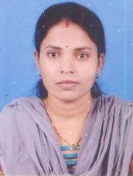
3 | Designation | Assistant Professor
4 | Date of Birth | 15/11/1983
5 | Unique –ID | 1-483564608
6 | Date of joining the Institution | 25th July, 2008
7 | Qualifications with Class/Grade | MBA, M. Com
8 | Total Experience in Teaching (Yrs.) | 15years
9 | • Work Experience | 15 Years
 | Teaching | 15 Years
 | Research | -
 | Industry | -
 | Others | -
10 | Area of Specilization | Marketing
11 | Courses taught at Diploma/ Post Diploma/ Under Graduate/ Post Graduate/ Post Graduate Diploma Level | Marketing Management, Services Marketing, Consumer Behavior, International Marketing, Entrepreneurship Development, Digital Banking
12 | • Research guidance (Number of Students) | 150
13 | No. of papers published in National/ International Journals/ Conferences | 6
14 | Master(Completed/Ongoing) | -
15 | Ph.D. (Completed/Ongoing) | Ph.D Registered at Savitribai Phule Pune University
16 | Projects Carried out | -
17 | Patents (Filed & Granted) | -
18 | Technology Transfer | -
19 | Research Publications (No.of papers published in National/International Journals/Conferences | -
20 | No. of Books published with details (Name of the book, Publisher with ISBN, year of publication, etc.) | -
21 | Ph. D Guide? | No
22 | Give field & University | N.A.
23 | Professional Memberships | 0
24 | Consultancy Activities | 0
25 | Awards | 1
26 | Grants fetched | 0
27 | Interaction with Professional Institutions | 0

1. | Name | Prof. Dada S. Patil
2 | Photo
3 | Designation | Assistant Professor
4 | Date of Birth | 27/07/1985
5 | Unique –ID | 1-472773389
6 | Date of joining the Institution | 16th July, 2008
7 | Qualifications with Class/Grade | B. C.A.MBA, (1st Class)
8 | • Work Experience | 14 years
 | Teaching | 14 years
 | Research | 1 year
 | Industry | 0
 | Others | 0
9 | Area of Specialization | Marketing
10 | Courses taught at Diploma/ Post Diploma/ Under Graduate/ Post Graduate/ Post Graduate Diploma Level | Marketing Management, Basic of Marketing, Sales and Distribution Management, Business to Business Management
11 | • Research guidance (Number of Students) | 150
12 | No. of papers published in National/ International Journals/ Conferences | 12
13 | Master (Completed/Ongoing) | NA
14 | Ph.D. (Completed/Ongoing) | NA
15 | Projects Carried out | NA
16 | Patents (Filed & Granted) | NA
17 | Technology Transfer | NA
18 | Research Publications (No.of papers published in National/International Journals/Conferences | 0
19 | No. of Books published with details (Name of the book, Publisher with ISBN, year of publication, etc.) | 0
20 | Courses taught at Diploma/ Post Diploma/ Under Graduate/ Post Graduate/ Post Graduate Diploma Level | Marketing Management, Basic of Marketing, Sales and Distribution Management, Business to Business Management
21 | Books Published / IPRs/ Patents | 01
22 | Professional Memberships | 0
23 | Consultancy Activities | 0
24 | Awards | 1
25 | Grants fetched | 0
26 | Interaction with Professional Institutions | 0
1. | Name | Prof. Dr. Omkar Gadre
2 | Photo
3 | Designation | Associate Professor
4 | Date of Birth | 24-july -1984
5 | Unique –ID | 1-472636205
6 | Date of joining the Institution | 01/06/2009
7 | Qualifications with Class/Grade | B.M.S. MMS, (1st Class), Ph. D.
8 | Total Experience in Teaching (Yrs.) | 13years
 | Research | -
 | Industry | 1 YR
 | Others | -
9 | Area of Specilization | Computer management
10 | Courses taught at Diploma/ Post Diploma/ Under Graduate/ Post Graduate/ Post Graduate Diploma Level | Business Analytics, MBA
11 | • Research guidance (Number of Students) | 100
12 | No. of papers published in National/ International Journals/ Conferences | YES – 5 (no.)
13 | Master (Completed/Ongoing) | Completed
14 | Ph.D. (Completed/Ongoing) | Completed
15 | Projects Carried out | NA
16 | Patents (Filed & Granted) | NA
17 | Technology Transfer | NA
18 | Research Publications (No. of papers published in National/International Journals/Conferences | NA
19 | Papers Presented in Conferences | 01
20 | No. of Books published with details (Name of the book, Publisher with ISBN, year of publication, etc.) | Yes -1(no.)
21 | Ph. D Guide? | No
22 | Give field & University | N.A.
23 | Books Published / IPRs/ Patents | 0
24 | Professional Memberships | 0
25 | Consultancy Activities | 0
26 | Awards | 0
27 | Grants fetched | 0
28 | Interaction with Professional Institutions | 0

1. | Name | Prof. Dr. Sampada Gupchup
2 | Photo | 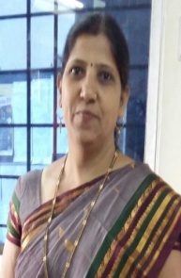
3 | Designation | Assistant Professor
4 | Date of Birth | 31st May, 1969
5 | Unique –ID | 1-472906425
6 | Date of joining the Institution | 16/08/2010
 | Qualifications with Class/Grade | M.A.(Eco.), PGDBM, MMS, (1st Class), Ph.D
7 | • Work Experience | 23 years
 | Teaching | 12 Years
 | Research | ----
 | Industry | -----
 | Others | 11 Years
8 | Area of Specilization | Economics, Marketing
9 | Courses taught at Diploma/ Post Diploma/ Under Graduate/ Post Graduate/ Post Graduate Diploma Level | Post Graduate, Post Graduate Level
10 | • Research guidance (Number of Students) | 50
11 | No. of papers published in National/ International Journals/ Conferences | 11
12 | Master (Completed/Ongoing) | completed
13 | Ph.D. (Completed/Ongoing) | Completed
14 | Projects Carried out | NIL
15 | Patents (Filed & Granted) | NIL
16 | Technology Transfer | Nil
17 | Research Publications (No.of papers published in National/International Journals/Conferences | Nil
18 | No. of Books published with details (Name of the book, Publisher with ISBN, year of publication, etc.) | Nil
20 | Papers Presented in Conferences | 01
21 | Ph. D Guide? | No
22 | Give field & University | N.A.
24 | Professional Memberships | 0
25 | Consultancy Activities | 0
26 | Awards | 0
27 | Grants fetched | 0
28 | Interaction with Professional Institutions | 0

1. | Name | Prof. Ashok Balbhim Kumbhar
2 | Photo | 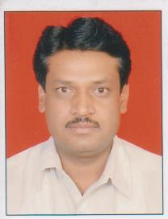
3 | Designation | Assistant Professor
 | Date of Birth | 28-7-1969
 | Unique –ID | 1-2188096902
4 | Date of joining the Institution | 13/08/2013
5 | Qualifications with Class/Grade | M.A. (Soc.), PGDBM, MBS (1st Class)
 | • Work Experience | 29 YRS
 | Teaching | 9 YRS
 | Research | NA
 | Industry | NA
 | Others | 20 YRS
 | Area of Specilization
 | Courses taught at Diploma/ Post Diploma/ Under Graduate/ Post Graduate/ Post Graduate Diploma Level | PGDBM, MBA., Marketing, Business Analytics
 | • Research guidance (Number of Students) | NA
 | No. of papers published in National/ International Journals/ Conferences | YES -6 (no.)
 | Master (Completed/Ongoing) | COMPLETED
 | Ph.D. (Completed/Ongoing) | NA
 | Projects Carried out | NA
 | Patents (Filed & Granted) | NA
 | Technology Transfer | NA
 | Research Publications (No.of papers published in National/International Journals/Conferences | YES 1 (no.)
 | No. of Books published with details (Name of the book, Publisher with ISBN, year of publication, etc.) | NA
7 | Papers Published National | 04
8 | Papers Presented in Conferences | 01
9 | Ph. D Guide? | No
10 | Give field & University | N.A.
11 | Books Published / IPRs/ Patents | 0
12 | Professional Memberships | 0
13 | Consultancy Activities | 0
14 | Awards | 0
15 | Grants fetched | 0
16 | Interaction with Professional Institutions | 0
1. | Name | Prof. Rohini U. Nikam
2 | Photo | 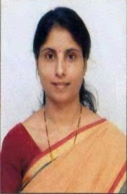
3 | Designation | Assistant Professor
4 | Date of Birth | 03/01/1977
5 | Unique –ID | 1-3536298760
6 | Date of joining the Institution | 01/07/2014
7 | Qualifications with Class/Grade | BSL .LL.B.,LL.M.,M.P.M.,Ph.D. Pursuing
8 | - Work Experience | 15years
 | Teaching | 15years
 | Research | -
 | Industry | -
 | Others | -
9 | Area of Specilization | Human Resource Management
10 | Courses taught at Diploma/ Post Diploma/ Under Graduate/ Post Graduate/ Post Graduate Diploma Level | PDPM,PGDM,DBM,LL.B.BBA,BCA,B.Com.,MBA
11 | - Research guidance (Number of Students) | 100
12 | No. of papers published in National/ International Journals/  Conferences | 7
13 | Master(Completed/Ongoing) | LL.M. -2006  MPM-2011
14 | Ph.D. (Completed/Ongoing) | Ongoing
15 | Projects Carried out | -
16 | Patents (Filed & Granted) | -
17 | Technology Transfer | -
18 | Research Publications (No.of papers published in National/International  Journals/Conferences | 7
19 | No. of Books published with details (Name of the book, Publisher with ISBN, year of publication, etc.) | 2  Business Law 2015  Research Methodology 2016
20 | Papers Published National | 03
21 | Papers Presented in Conferences | 01
22 | Ph. D Guide? | No
23 | Give field & University | N.A.
24 | Books Published / IPRs/ Patents | 0
25 | Professional Memberships | 0
26 | Consultancy Activities | 0
27 | Awards | 0
28 | Grants fetched | 0
29 | Interaction with Professional Institutions | 0

1. | Name | Dr. Renuka Amit Vanarase
2 | Photo | 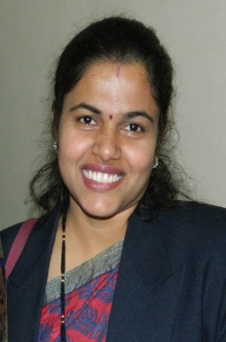
3 | Designation | Assistant Professor
4 | Date of joining the Institution | 02/07/2007
5 | Qualifications with Class/Grade | B.A., M.C.M., P.G.D.B.M., M.B.S. Ph.D.
6 | Total Experience in Teaching (Yrs.) | 15 Years
7 | Papers Published National | 05
8 | Papers Presented in Conferences | 01
9 | Ph. D Guide? | No
10 | Give field & University | N.A.
11 | Books Published / IPRs/ Patents | 0
12 | Professional Memberships | 0
13 | Consultancy Activities | 0
14 | Awards | 1
15 | Grants fetched | 0
16 | Interaction with Professional Institutions | 0
1. | Name | Dr. SmitaAmeyWagh (Kshirsagar)
2 | Photo | 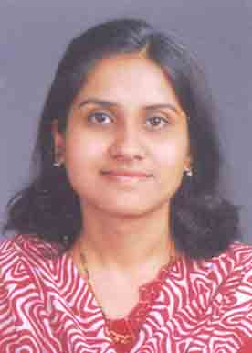
3 | Designation | Assistant Professor
 | Date of Birth | 27th January 1985
 | Unique –ID | 1-3536298617
 | Date of joining the Institution | 01/09/2010
 | Education Qualification | MCM, MBS, Ph.D
 | • Work Experience
4 | Teaching | 11 years
 | Research | 0
 | Industry | 0
 | Others | 0
 | Area of Specilization | Marketing and IT
 | Courses taught at Diploma/ Post Diploma/ Under Graduate/ Post Graduate/ Post Graduate Diploma Level | - Basics of Marketing  - Marketing Management  - Digital Business  - Project Management  - Services Marketing
 | • Research guidance (Number of Students) | 100
 | No. of papers published in National/ International Journals/ Conferences | 1 paper in UGC listed journal  3 papers in State level publications  5 papers in National journals
 | Master (Completed/Ongoing) | Completed
 | Ph.D. (Completed/Ongoing) | Completed
 | Projects Carried out | 0
 | Patents (Filed & Granted) | NIL
 | Technology Transfer | NIL
 | Research Publications (No.of papers published in National/International Journals/Conferences | - Wagh, S. A. "A Role of Training for Employee Retention" (2015, Ed.) Printing Area International Research Journal (ISSN-2394-5303), 31-36.  - 2. Wagh, S. A. "A Study of Talent Rentention: Challenges Faced by ITES in India". (2015, Ed.) Challenges and Opportunities for Indian Economy (ISBN978-93-83-993-96-3), 144-148.  - Wagh, S. A. "The Study of Increasing Trend of Distance Education in 21st Century in India". (2015, Ed.)Innovation(ISBN-9789352024407), 217-221.  - Wagh, S. A. "A Study of IT industries Progression in India Since it's Inception, With Speical Reference ot Global Market". Innovation.  - Wagh, S.A. “A Study of Effectiveness of Massive Online Courses to Bridge the Educational Gap”, (2019, Ed.) SIMCA-National conference.  - Wagh, S. A. “A study of Impact of social media in Online Shopping on the Buying Choices of Shoppers (PCMC area)” (2019, Ed.) VU International Conference.  - Smita Wagh, D. R. (February-2019). "A STUDY OF EFFECTIVENESS OF MASSIVE ONLINE COURSES TO BRIDGE THEEDUCATIONAL GAP". IJRAR- International Journal of Research and Analytical Reviews (IJRAR), Volume.6(Issue 1), Page No pp.53-59. Retrieved from http://www.ijrar.org/IJRAR19UP008.pdf  - Wagh, S. (2020, February). A Study of Factors Affecting Employability of BSchool/ Management Institutes Graduates in Pune City. IJCRT, Volume 8( Issue 2), 251-255. Retrieved from http://www.ijrar.org/IJRAR19UP008.pdf  - Wagh, S.A. “The study of Impact of online shopping on retail business with special reference to Mobile hand set Market in selected areas of Pune city”. DogoRangsang Research Journal, Volume-10, Issue-06, No-9, Page no- 186-195, ISSN- 2347-7180 www.drsrjournal.com
 | No. of Books published with details (Name of the book, Publisher with ISBN, year of publication, etc.) | 1 Book published.  Sr. No Name of the Book Publisher ISBN No Year of Publication  1. “Creating Talent Pool of Trained and Skilled IT Professionals to Cope up with Emerging Needs of IT Industry” Empyreal publishing house 978-81-943209-9-9 2019
7 | Papers Published National | 3
8 | Papers Presented in Conferences | 0
9 | Ph. D Guide? | 0
10 | Give field & University | 0
11 | Books Published / IPRs/ Patents | 0
12 | Professional Memberships | 0
13 | Consultancy Activities | 0
14 | Awards | 0
15 | Grants fetched | 0
16 | Interaction with Professional Institutions | 0

1. | Name | Mr. Mahendra Sudam Kamble
2 | Photo | 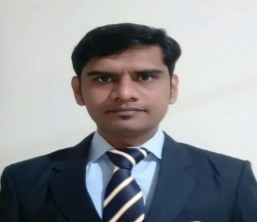
3 | Date of Birth | 15/06/01985
4 | Unique –ID
5 | Education Qualification | M.lib. I. Sc. SET
6 | • Work Experience | 3.6 Years
 | Teaching | -
 | Research | -
 | Industry | -
 | Others | -
7 | Area of Specilization | Library Science
8 | Courses taught at Diploma/ Post Diploma/ Under Graduate/ Post Graduate/ Post Graduate Diploma Level | -
9 | • Research guidance (Number of Students) | -
9 | No. of papers published in National/ International Journals/ Conferences | 1
10 | Master (Completed/Ongoing) | -
11 | Ph.D. (Completed/Ongoing) | -
12 | Projects Carried out | -
13 | Patents (Filed & Granted) | -
14 | Technology Transfer | -
15 | Research Publications (No. of papers published in National/International Journals/Conferences | -
16 | No. of Books published with details (Name of the book, Publisher with ISBN, year of publication, etc.) | -

14 | Admission quota |  | 80 % intake is filled up through Centralized Admission Process conducted by the Admission Authority Cell of the State.
 | Entrance Test/Admission Criteria |  | As per the notifications published by the State Common Entrance Cell, Mumbai from time to time.
 | Cut off/last candidate admitted |  | N.A.
 | CAY | CAY-1 |  |  |  | CAY-2
 | Fees in rupees
 | CAY | CAY-1 |  |  |  | CAY-2
 | Rs. | Rs. 1,16,000.00 (INR) |  |  |  | Rs. 1,05,000.00(INR)
 | Number of fee waiver N.A.
Admission Calendar
The Schedule given by Directorate of Technical Education varies every year hence the calendar published in the CET brochure is followed strictly and is monitored by DTE, Maharashtra.
 | PIO Quota |  |  | Not Applicable
 | Infrastructural Information
 | Classroom/Tutorial Room |  |  | 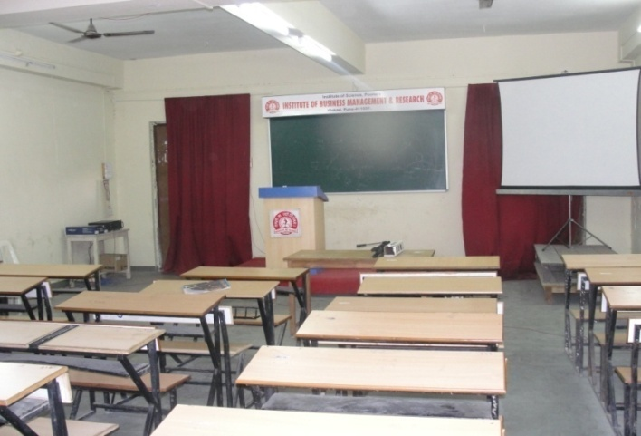
 | Computer Centre facilities |  |  | 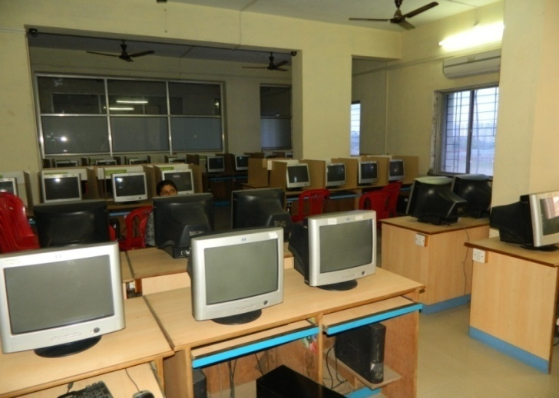
 | Library Facility |  |  | 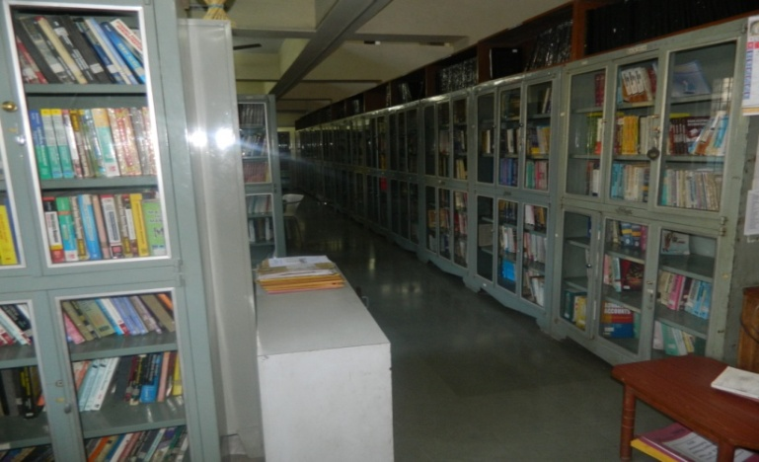
 | Auditorium / Seminar Halls / Amphi Photo |  |  | 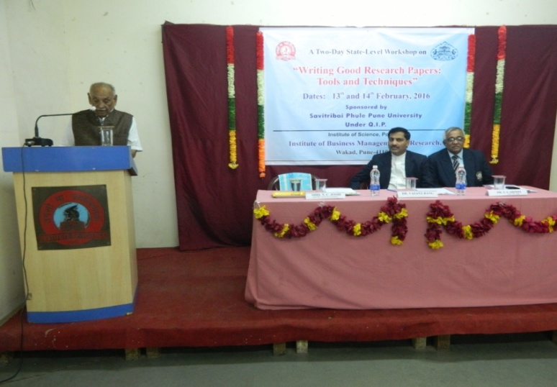
 | Seminar Hall: Seminar in Progress: |  |  | 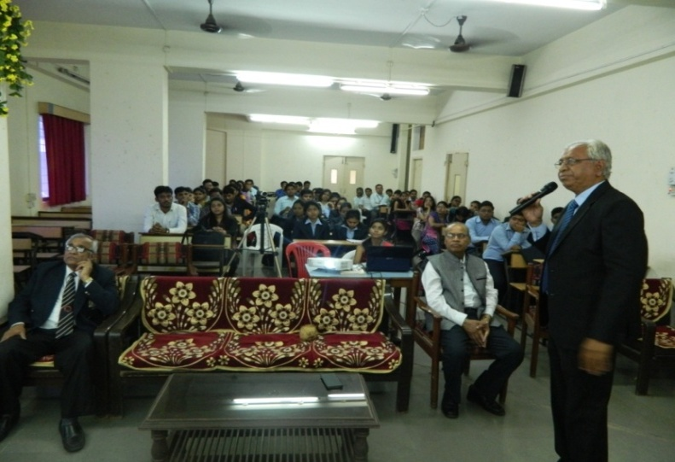
 | Cafeteria Photo |  |  | 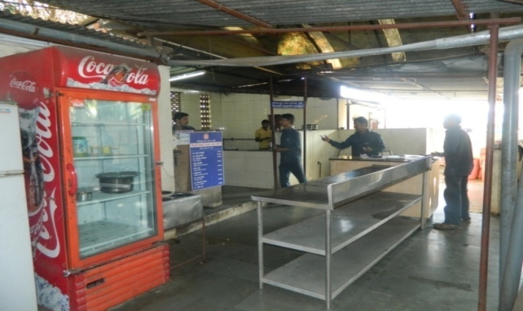
15 | Teaching Learning Process |  |  | Syllabus  Acdemic Calender:  Time Table:  Teaching Load:  Internal Continues Evaluation System:  Student Assesment of Faculty System:
16 | Enrolment and placement details of students in last three years
17 | List of Research Project/ Consultancy work
 | Name of the Organization |  |  | Type of Industry Linkage
 | Smart Trade
 | Aarohi Info
 | Max Education
 | Reliable
 | Revell
 | Rucha Edu
18 | LOA and subsequent EoA till the current Academic year
19 | Accounted audited statement for the last three yeas
20 | Best Practices adopted |  |  | Best Practices adopted:
 | Academic Sessions |  |  | System as per Savitribai Phule Pune University
 | Examination system, Year/Sem. |  |  | I & III Semester exams in Nov/Dec.  II & IV Semester exams in April/May
 | Period of declaration of results |  |  | Within 40 days from the date of last paper
21 | Counseling Mentoring |  |  | Yes
 | Carrier Counseling |  |  | Yes
 | Medical facilities |  |  | Available
 | Student Insurance |  |  | Yes
22 | Students Activity Body |  |  | Yes
 | Cultural activities |  |  | Yes
 | Sports activities |  |  | Yes
 | Literary activities |  |  | Yes
 | Magazine/Newsletter |  |  | Yojak
 | Technical activities/Tech Fest |  |  | Hackathon
 | Industrial Visits/Tours |  |  | Yes
 | Alumni activities |  |  | Snehbandh
23 | Name of the Information Officer for RTI |  |  | Mr. Ashok Kumbhar
 | Designation |  |  | Asst. Professor – Office Superintendent (Additional charge)
 | Phone. No with STD Code |  |  | 020-67174200
 | Fax No with STD Code |  |  | 020-67174200
 | E-mail |  |  | ibmrwakadpune@ibmerpune.in
 | Website |  |  | www.ibmrpune.in
 | NBA Accreditation Status
1 | Name/ List of Programmes/ Courses Accredited
2 | Applied for Accreditation |  |  |  | -
 | - Applied but visit not happened |  |  |  | -
 | - Visit happened but result awaited |  |  |  | -
3 | List of Programmes/ Courses Not Applied |  |  |  | M.B. A
 | NAAC Accreditation Status
1 | Accredited |  |  |  | B
 | Applied Accreditation
 | - Applied but visit not happened |  |  |  | -
 | - Visit happened but result awaited |  |  |  | -
 | Not Applied |  |  |  | -

Pune Shri. Prasad N. Joshi
Dated: Trustee & secretary
Bnvc Institute of Science, Poona

